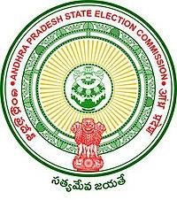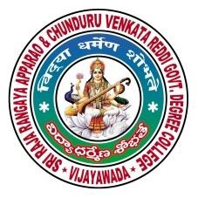SRR & CVR GOVERNMENT DEGREE COLLEGE

# VIJAYAWADA, KRISHAN DIST., A.P

NAAC B+GRADE(CGPA:2.60)

DEPARTMENT OF URDU

EFFTRONOCS

VIJAYAWADA

# **(FIElD VISIT)**

**DATE: 22-06-2022**





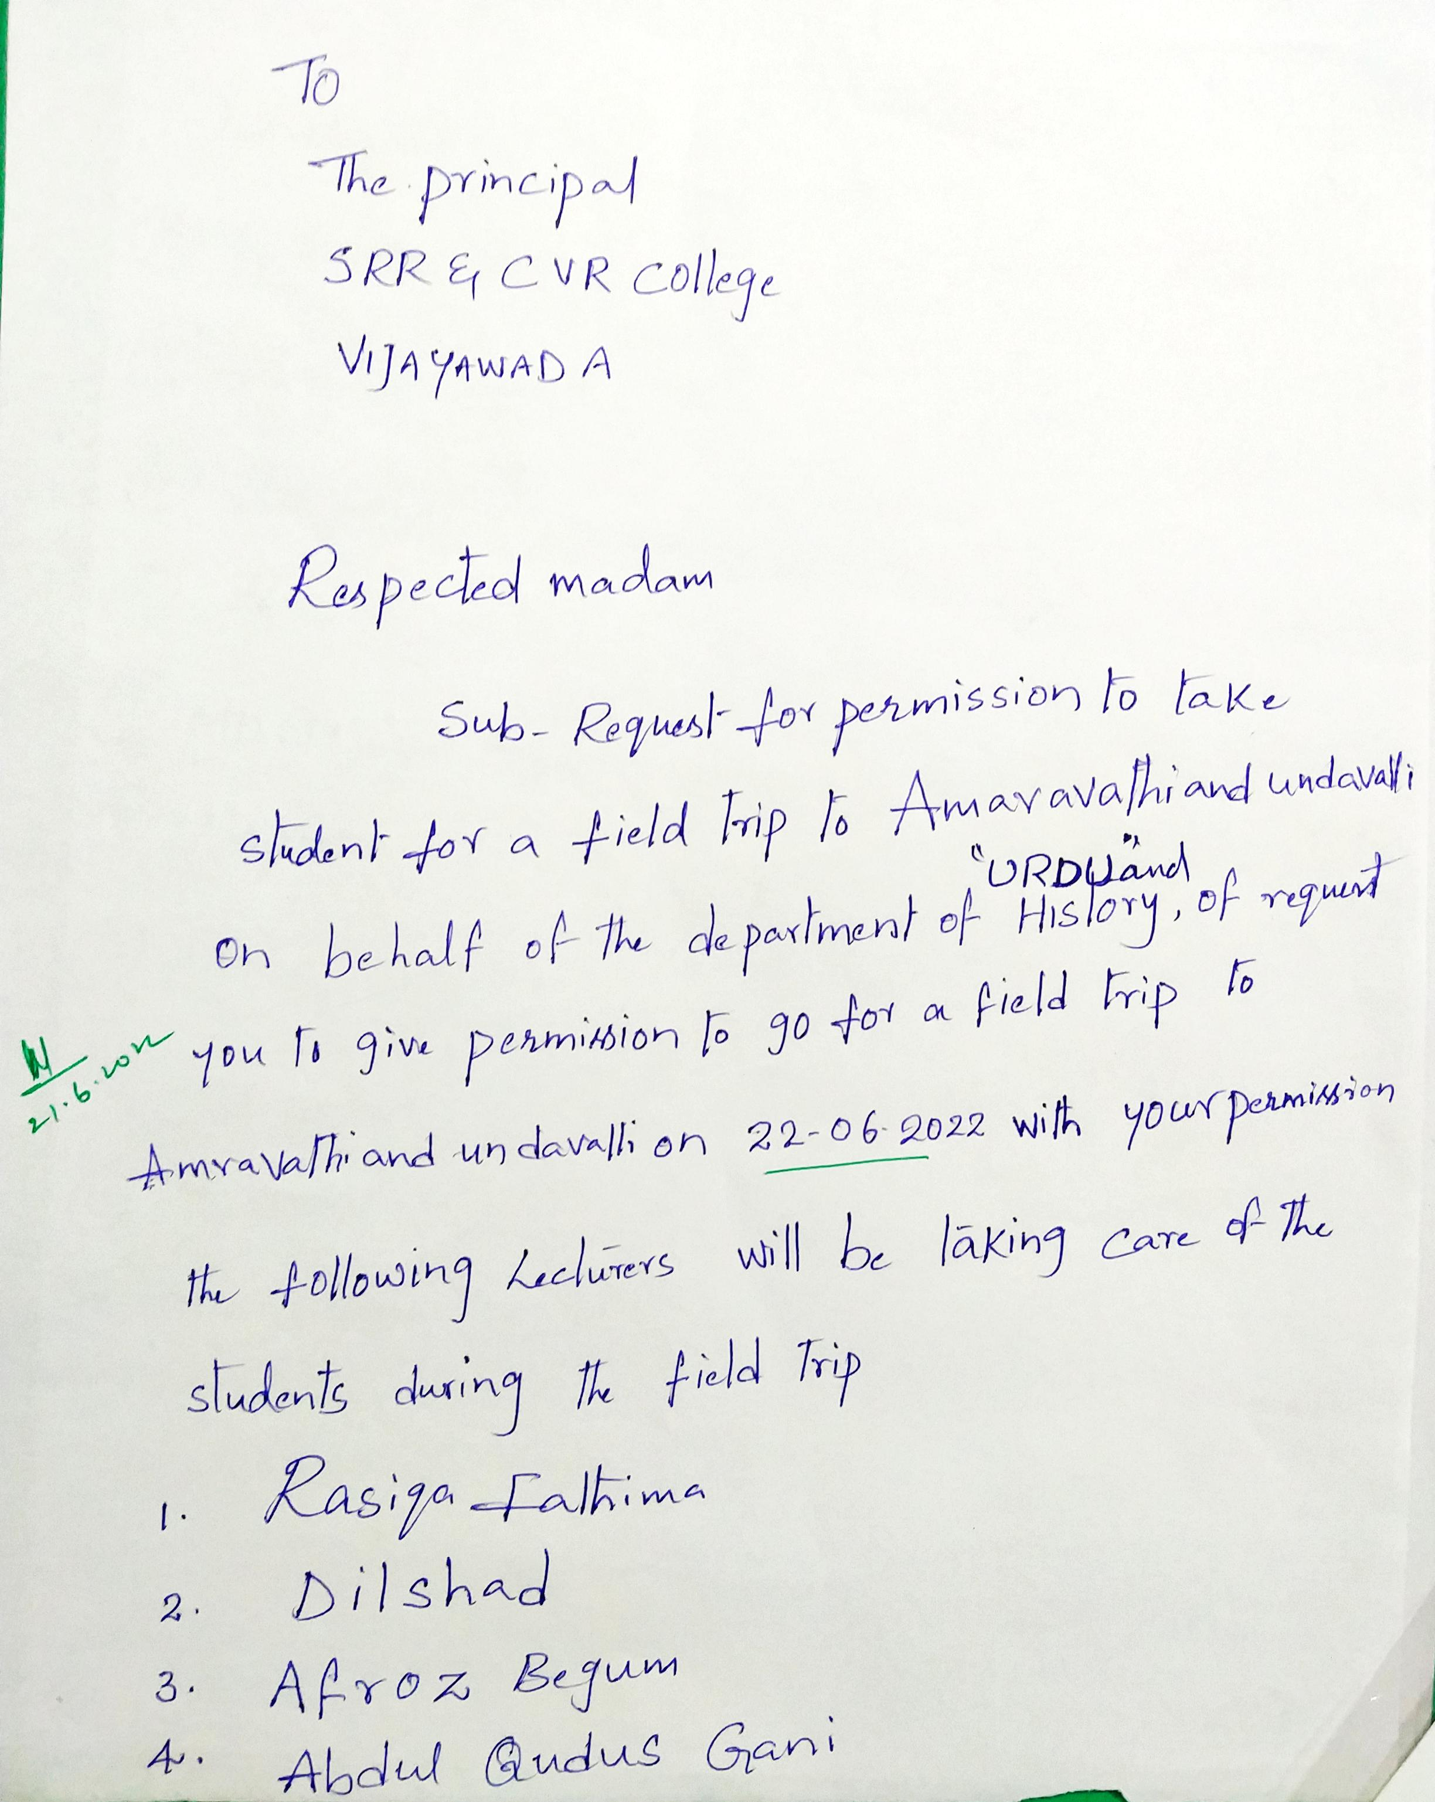

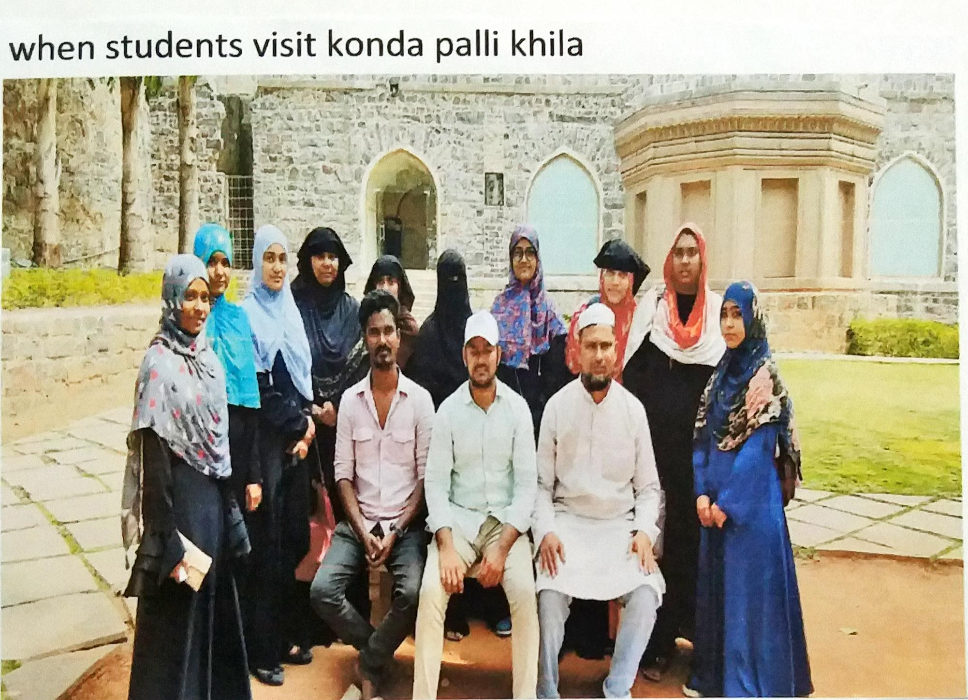



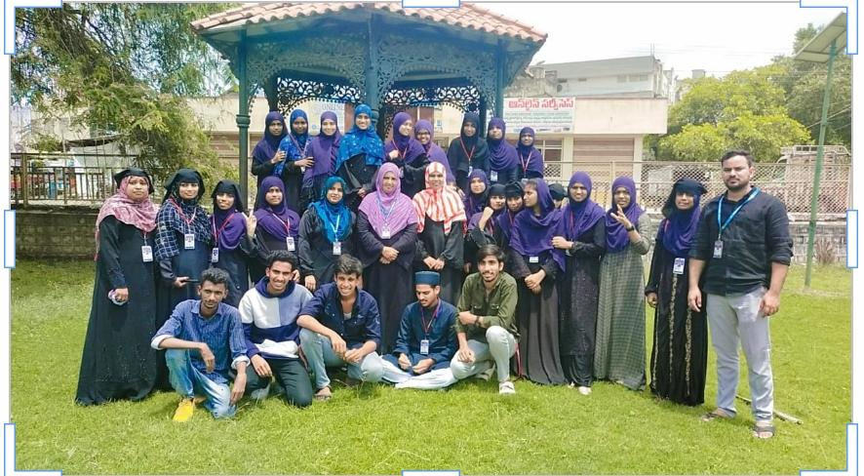

The presentation given by ***AFROZ BEGUM*** and **RASIQA FATHIMA**, **GANI ABDUL QUDDUS KUM.DILSHAD GARU,** about radar systems and then practically viewed the working of radar system, we are very much of inspired and gain the knowledge on detection the cyclones, their wind range and rainfall, measuring humidity.

**Student Feed Back:**

In our BA, EHP (U/M) life, now we have stepped into our final year which is very precious for us and we believe in and dying for only four things.

* ***Gaining knowledge***
* ***Hard work***
* ***success***

As a way to reach all these three goals, we and our beloved faculty planned to go to radar station to have a practical look about - How radar systems are working? First time when we students heard that we are going to radar station our souls are very excited and bloomed with happiness. It was for the first time that all our friends without any failure in the total strength are going to have a short journey and we dreamed that’ ***we will rock the tour’***. We science students are the Y of ***Dr. A.P.J.Abdul Kalam*** who messaged us that ***“DARE TO DREAM, DIE TO ACHIEVE IT”.*** so we dreamed and met the success.

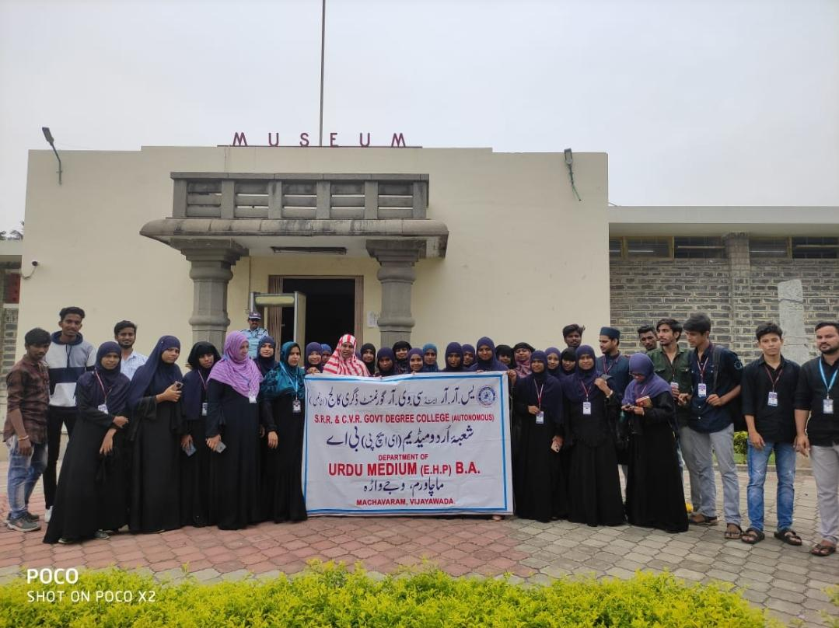

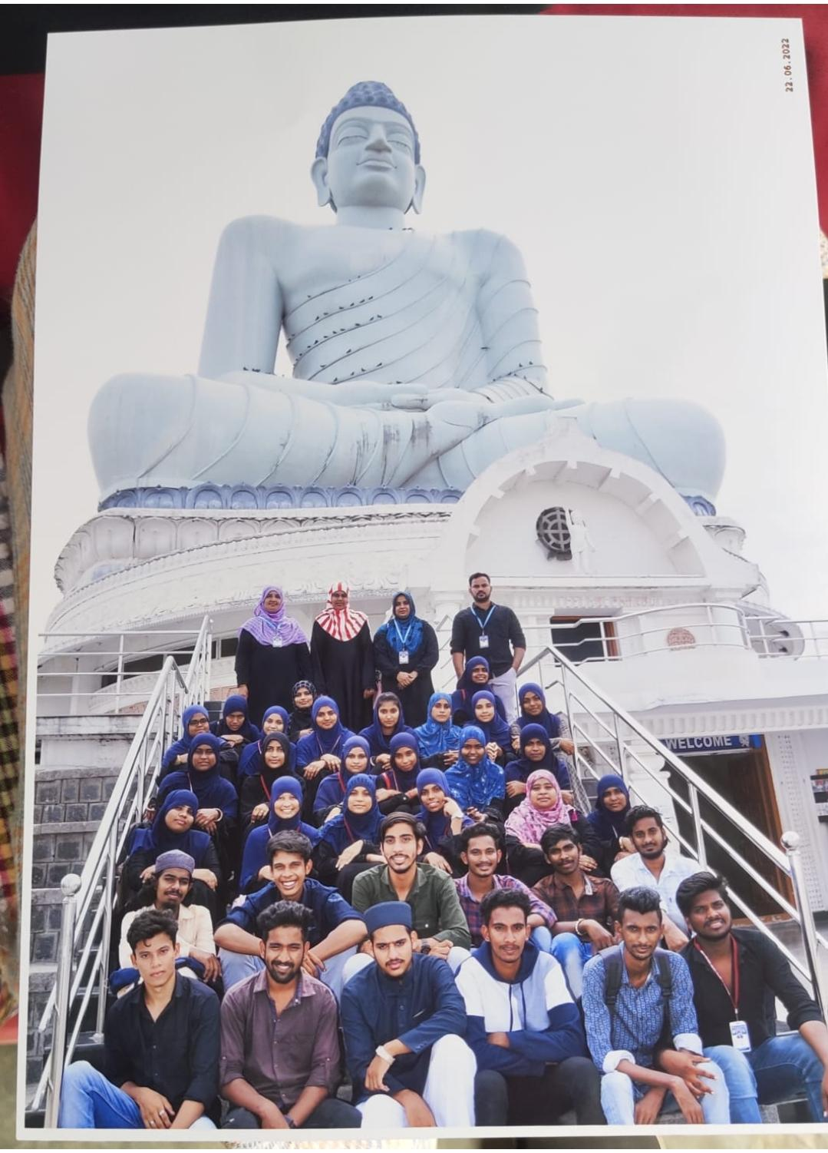

## ATTENDANCE

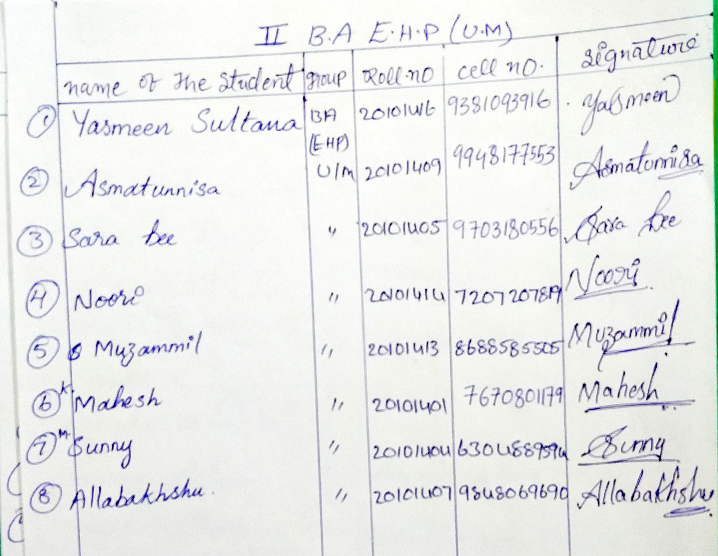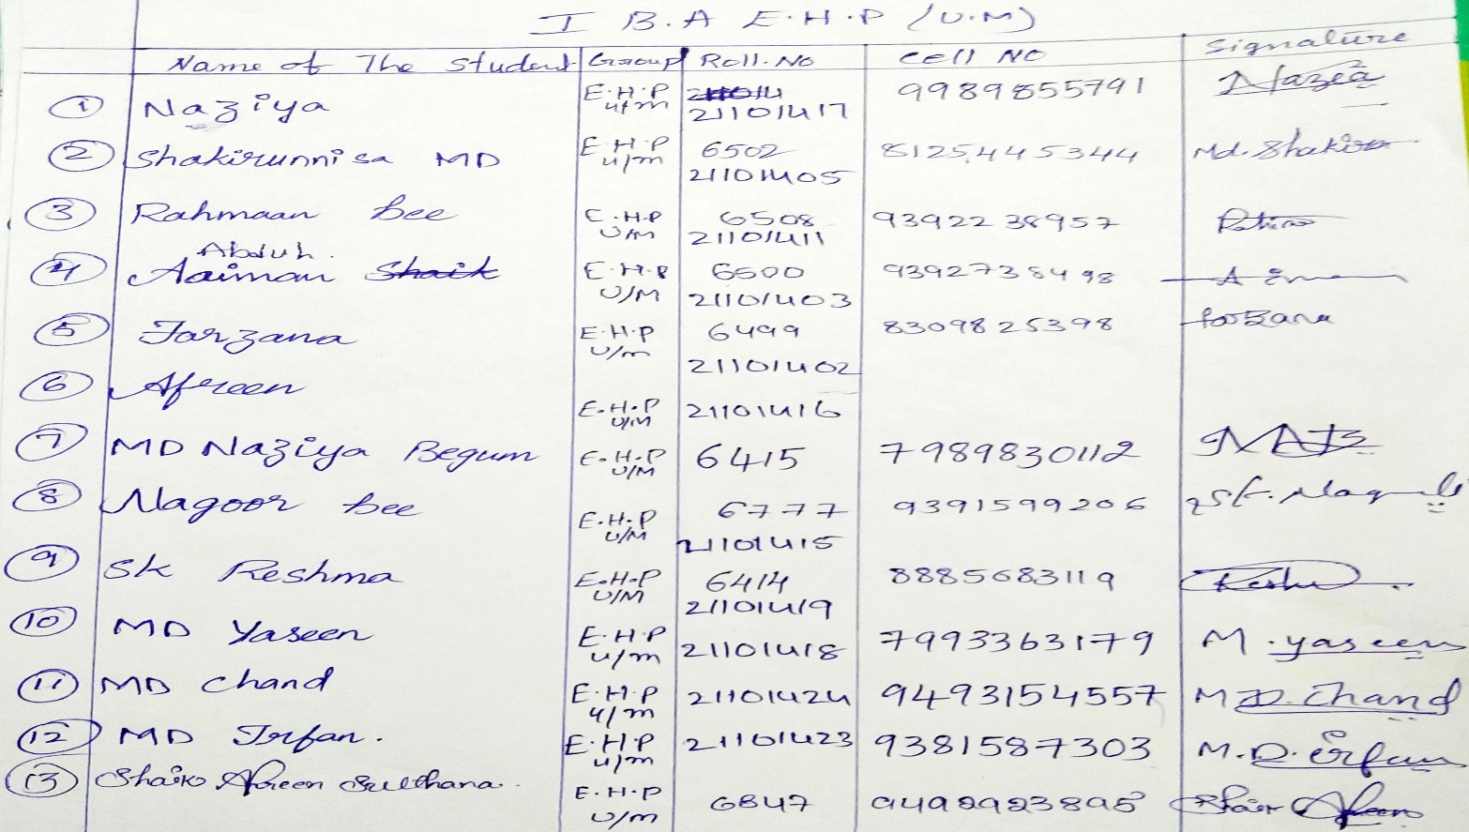

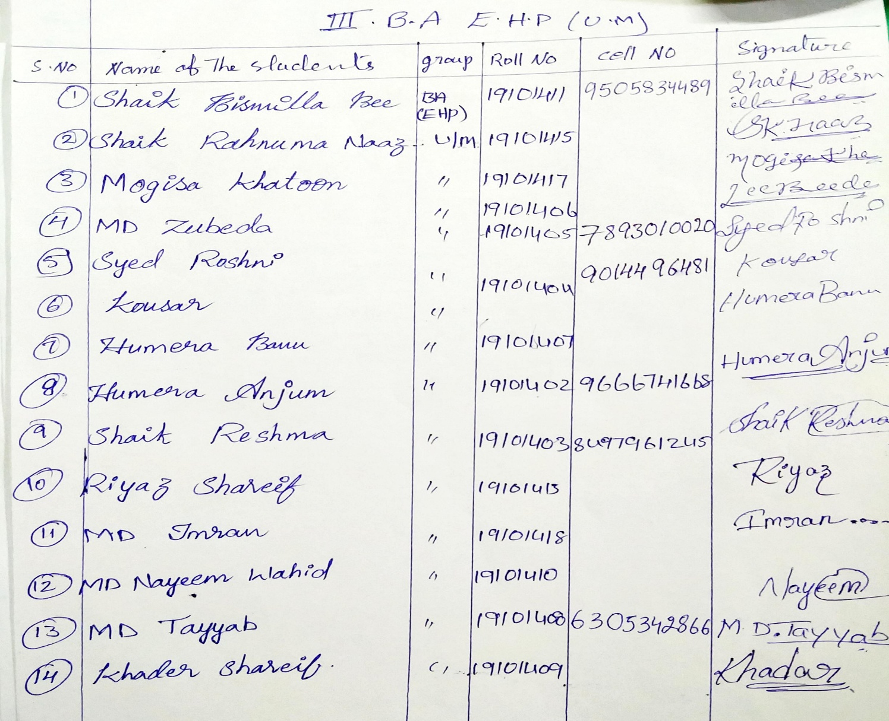

**ACKNOWLEDGMENT**

Thanks to the Principal sir **Dr. Bhangya Lakshmi madam garu**, and our Departnemnt

Incharge **smt. Afroz begum** garu and other faculty of the department. I thank to the **Rasiqa Fathima,** **Gani Abdul Quddus** and **Kum.Dilshad** garu , by their cooperation our Students get the knowledge of working the radar station with practical approach, with all the elder ones and their blessings we are successfully completed the Tour.